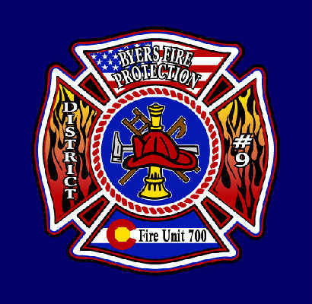

### **BYERS FIRE PROTECTION DISTRICT #9**

#### 100 N. Main Phone – 303.822.5208

#### P.O. Box 85 Fax – 303.822.5551

**Byers, CO 80103** **Email –** [**admin@byersfire.org**](mailto:admin@byersfire.org)

**CALL FOR NOMINATIONS**

**FOR THE REGULAR ELECTION**

**BYERS FIRE PROTECTION DISTRICT NO. 9**

**TO WHOM IT MAY CONCERN**, and, particularly, to the electors of the BYERS FIRE PROTECTION DISTRICT NO. 9 of Adams, Arapahoe and Elbert Counties, Colorado.

**NOTICE IS HEREBY GIVEN** that the District’s regular election will be held on Tuesday, May 6, 2025, between the hours of 7:00 a.m. and 7:00 p.m. At that time, three (3) directors will be elected to serve four (4) year terms. Eligible electors of the Byers Fire Protection District No. 9 interested in serving on the board of directors may obtain a Self-Nomination and Acceptance form from the District’s Designated Election Official (DEO):

Constance Shields (DEO)

100 N. Main Street, Byers, Colorado 80103

303-822-5208 Office

You must call Constance Shields (DEO) for an appointment at 303-822-5208 Office.

The Office of the DEO is open Monday, Wednesday and Friday from 9:00 a.m. to 1:00 p.m.

Self-Nomination and Acceptance forms must be filed with the DEO at the above address not less than 67 days prior to the election (Friday, February 28, 2025). **The deadline to submit a Self-Nomination and Acceptance is close of business on Friday, February 28, 2025.**  If the DEO determines that a Self-Nomination and Acceptance form is not sufficient, the eligible elector who submitted the form may amend the form once, at any time, prior to 3:00 p.m. on Friday, February 28, 2025.Earlier submittal is encouraged as the deadline will not permit curing an insufficient form. Affidavit of Intent to be a Write-In-Candidate forms must be submitted to the office of the DEO by the close of business on **Monday, March 3, 2025** (the sixty-fourth day before the election).

BYERS FIRE PROTECTION DISTRICT NO. 9

/s/ Constance Shields - Designated Election Official (DEO)